**Assignment Four**

**Data analysis tools analytics Data-1202**

**Report for Group 1 log**

**Anna Edwards-Almendares**

**Vugar Imamverdiyev**

**Priyanshi Jain**

**Chittajallu, Sainadh**

**Galinki, Bhanodhay**

Answer the following:

* Create a function to calculate the distribution of channeltype **from the top 1000 records.**
* Load only the top 1000 records of the original 4000 into a separate CSV file, and to a database table.

Submit the following:

1. Provide a document that includes your function and how you called your function.
2. Also include the loaded CSV or a screenshot of a SELECT from your SQL table with the loaded data.

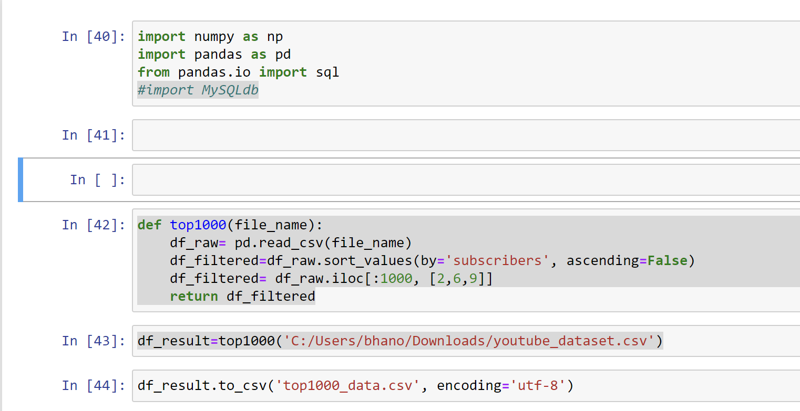

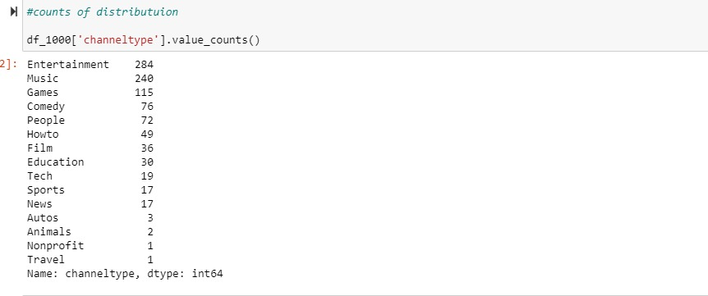

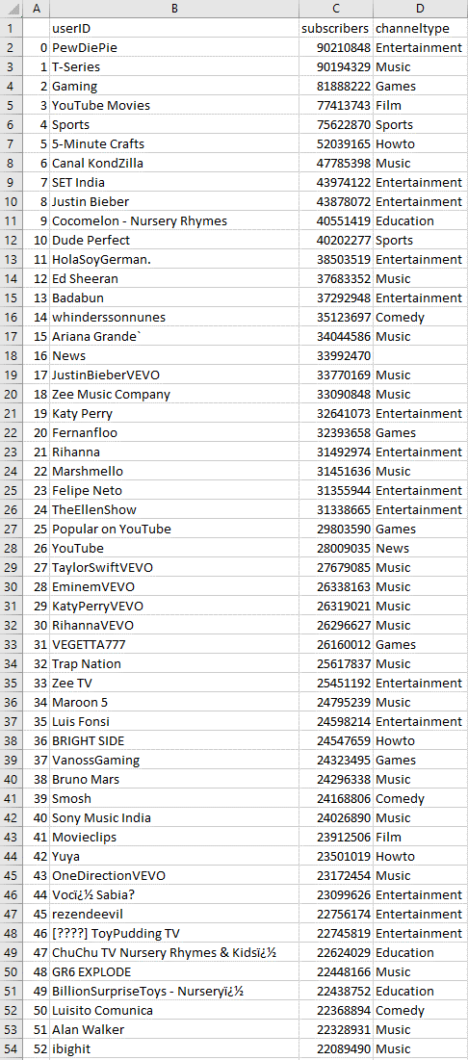

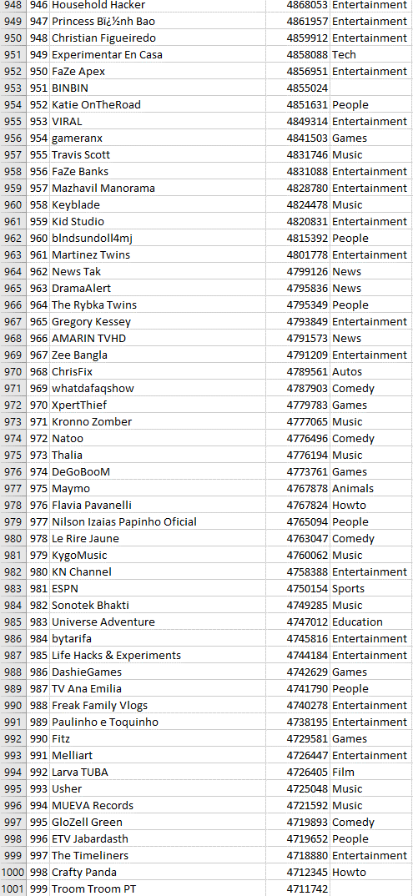

*We created a function to return the top 1000 records from the dataset in the form of a .csv file

|  |  |  |  |
| --- | --- | --- | --- |
| **LOG SHEET** | | | |
| **START DATE** | **END DATE** | **CONTRIBUTION** | **NAME** |
| July 15,2022 | July 15,2022 | Did the code for question 1 | Anna Edwards-Almendares |
| July 15,2022 | July 15,2022 | Made the log sheet | Priyanshi Jain |
| July 15,2022 | July 15,2022 | Collected and organized the required information in word and made the report | Anna Edwards-Almendares |
| July 15,2022 | July 15,2022 | Scheduled the meeting every day and helped in coding question 1&2 | Sainadh Chaittajallu |
| July 15,2022 | July 15,2022 | Made the final changes in the report and helped in coding question 1 &2 | Bhanodhay Galinki |

**Report**

The assignment was difficult to connect with teammates, with time and schedule around people’s life. but our group did great in communicating and figuring out the meet times and the question being asked. we used each other’s skills, good, and YouTube to figure out the question.

In the previous class, we had used the filtered function came to find and the iloc function came to mind.

We began with the iloc function and started counting the columns. We proceed to complete the second question and finished on time. We took our time reading the assignment and not rushing. This assignment made us learn by learning it’s not a race and to slow down and not rush through each question.

**THANK YOU**